**Sale of Maltese passports nets Malta over €277m in one year, Henley & Partners get over €13m**

Tuesday, 23 January 2018, 13:53Last update: about 4 hours ago

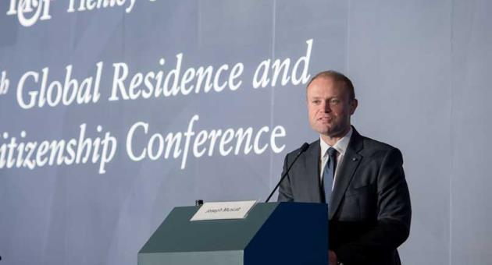

Over €277 million coming from the IIP programme was distributed between the National Development and Social Fund and the Consolidated Fund, an annual report by the Office of the Regulator for the IIP programme shows.

The report covers the period from 1 July 2016 to 30 June 2017.

During the period under review, the contributions collected by the Identity Malta Agency amounted to €290,225,000. “The contributions so collected initially go into a Suspense Account and it is only after the Oath of Allegiance is taken that the distribution of funds is carried out in accordance with the provisions governing the Individual Investor Programme (IIP).”

**ADVERTISEMENT**

The report explained that during this period, the funds distributed saw €194,381,249 go to the National Development and Social Fund, and €83,306,249 go to the Consolidated Fund. In addition, €16,440,000 went to the Identity Malta Agency and €13,212,000 to Henley & Partners.

“This means that since the launching of the IIP till the 30th June 2017, the total amount of funds distributed is as follows: €249,328,799 the National Development and Social Fund; €106,855,199 the Consolidated Fund; €23,701,500 Identity Malta Agency; €19,054,000 Henley & Partners.Q

The report reads that the balance in the Suspense Account, which was still awaiting distribution, as on 30 June 2017 stood at €110,435,502.

**377 applications**

The report read that the number of applications to the Identity Malta Agency during this period amounted to 377, an 18% decrease when compared with the number of applications received during the previous 12 months (451).

The largest number of applicants, the report reads, come from Europe (168). 81 applicants come from Asia, 51 from the Middle East, 31 from the Gulf, 21 from Africa, 18 from North America, 4 from South America, 2 from Oceania and 1 from the Caribbean.

The report also notes that the number of dependants included in the 377 applications amounted to 962, “which is less than the amount registered during the previous year (1188). This is mainly due to the afore-mentioned decrease in the number of applications.” The report notes that the average  number of dependants per application amounted to three.

As for approved applications, the report states that “the amount of applications which were approved (i.e. applications for which the due diligence has been positively concluded and a letter of approval in principle has been issued) was 422. This constitutes a significant increase from the previous year (241) and also from the year before that (75).”  It is pertinent to note that the reason as to why these figures do not tally with those recorded in terms of applications is as there is a time-lapse during which an application is processed.

The number of withdrawn or rejected applications during the period in question stood at 83.

During the period in question 386 applications had reached the final stage (i.e. when the naturalisation process was completed). “This constitutes a significant increase from the amount recorded during the previous 12 months, which stood at 137.” With respect to this final stage, the 386 applications included a total of 1409 persons. Apart from the 386 main applicants there were 294 spouses, 487 minor dependants and 242 adult dependants.

With regards to the employment status of the naturalised main applicants, the absolute majority (57%) declared that they were self-employed. The educational level of naturalised main applicants remained extremely high with around 69% reaching a degree level, Masters level or PHD level, the report read.

**Property**

The IIP Regulations oblige the main applicant to invest in a residential immovable property in Malta, either by acquiring and holding one having a minimum value of three hundred and fifty thousand euro (€350,000) or by taking one on lease for a minimum annual rent of sixteen thousand euro (€16,000). “In this regard, during the period in question there were 386 properties that were either purchased or leased.” During this period, 46 properties were bought and 340 leased according to the report. “The value of the 46 purchased properties amounted to €35,284,168.97, averaging €767,047.15 per property.”

The report also notes that IIP Regulations state that an IIP applicant shall make a minimum investment of €150,000 in Malta Government Stocks. “In this regard, the amount invested in such Stocks between July 2016 and June 2017 totalled €58,371,279.83. Taking into consideration all investments made since the launch of the Programme the total amount would add up to €85,873,164.71.”

The total number of Accredited Agents as at the end of June 2017 now stands at 141, an increase of 9 when compared with the amount registered a year before. The agents are divided into four categories – Legal (46);  Financial Fiduciary and Trust (58); Management and Consultancy (24); Property Consultancy (13).